Name:
Instution affiliation:
Subject:
Date:

6.
GRAPH of the system of linear inequalities
{(X,Y)|X+Y ≤-2,XƐ I ,YƐI}
{(X, Y)|2Y≥X, XƐ I, YƐI }
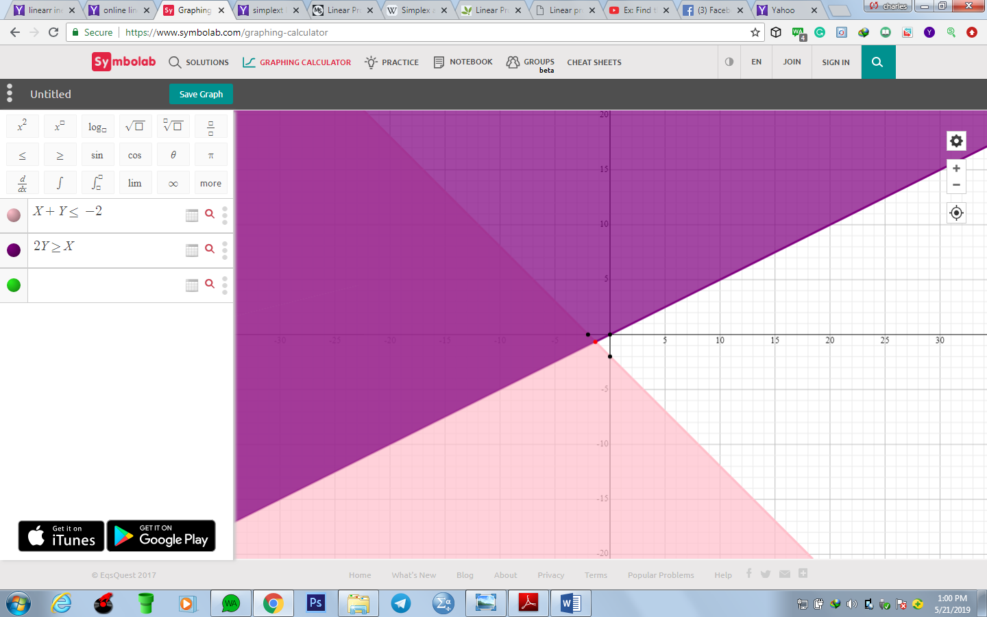
7.
a. let x be the red dye and y be the brown dye
b. restriction
x, y Ɛ positive real numbers
c. system of linear inequalities.
200> x+Y
2x≥y
d. graph
200ml=0.2 l

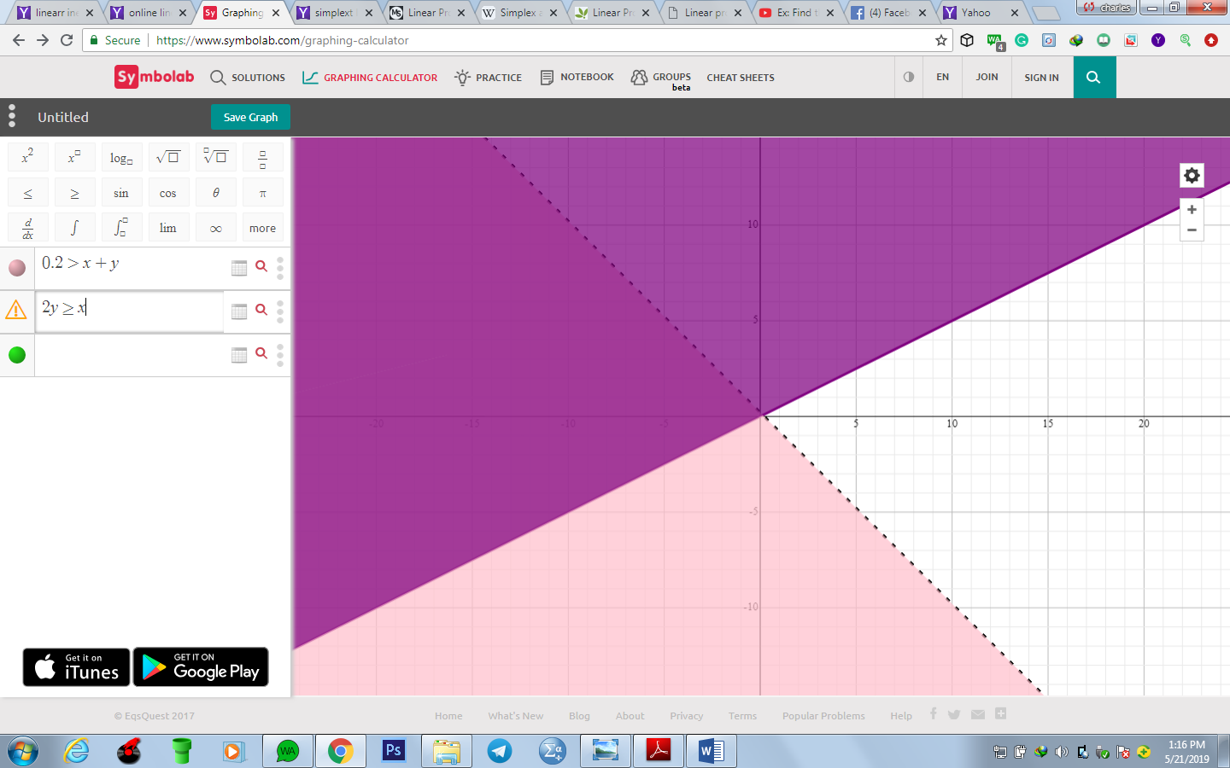

8. linear inequalities
Let x be a number of car and y be the number of trucks.
Let 20X+35Y=C where c is the maximum revenue
Constrain
X+Y<100
100X+200Y<12000,
c-20x-35Y=0;
x+y-a=100
100x+200y-b=1200
1st iteration
X | Y | A | B
1 | 1 | -1 | 0 | 100
100 | 200 | 0 | -1 | 12000
-20 | -35 | 0 | 0 | 0

2nd iteration
X | Y | A | B
-0.5 | 0 | 1 | -0.005 | -40
0.5 | 1 | 0 | -0.005 | 60
-2.5 | 0 | 0 | -0.175 | 2100

3rd iteration
X | Y | A | B
1 | 0 | -2 | 0 | 80
0 | -1 | -1 | -0.005 | -20
0 | 0 | 5 | -0.1625 | 1950

The above shows that x=80
Y=20
And c=1950
Therefore x=80 and y=20 are the number of cars and truck respectively that will bring maximum revenue of $1950.
Multiple choice questions
12. Answer = C
13. Answer = B and D
14. Answer = B
15. Answer =A
16. Answer = C
17. Answer =B
18. Answer =D
19. Answer =B
20. Answer =D

